University Privacy Campaign

Introduction to the

Personal Data (Privacy) Ordinance

1

Personal Data (Privacy) Ordinance

Legislative Background

• Personal Data (Privacy) Ordinance came into effect on 20

December 1996

• Based on internationally accepted data protection principles

• Legal privacy right in the handling of personal data

• Legal cross-border transmission of personal data to

facilitate the development of e-commerce

2

Personal Data (Privacy) Ordinance

Amendment of the Ordinance

• Gazette published on 6 July 2012

• Reasons for amendment:

– came into effect more than 15 years

– rapid advancement in information technology and widespread use of the Internet

– commercial value of personal and the growing popularity of e-commerce

– misuse of personal data and frequent occurrence of data leakage

– enhancing personal data protection by keeping in line with the international standard

3

Personal Data (Privacy) Ordinance

Amendment of the Ordinance

•Effective dates of the Amendment Ordinance:-

1) provisions unrelated to direct marketing or the legal assistance
scheme took effect on 1 October 2012;

2) provisions relating to direct marketing and the legal assistance
scheme came into effect on 1 April 2013;

4

Objectives of the Ordinance

• Protecting the privacy right of a “data subject” in respect of “personal data”, but general privacy issues are not protected.

“Data Subject”

A data subject refers to the living individual who is
the subject of the “personal data” concerned.

5

Definitions under the Ordinance

“Personal Data” should satisfy three conditions:

(1) relating directly or indirectly to a living individual;

(2) from which it is practicable for the identity of the individual to be directly or indirectly ascertained; and

(3) in a form in which “access to” or “processing of”
the data is practicable.

6

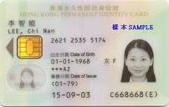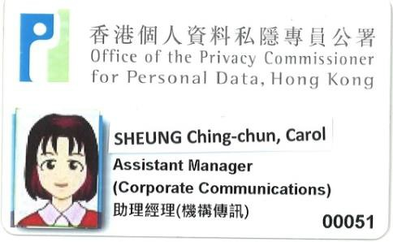Definitions under the Ordinance

“Data”:
any representation of information in any document,
including expression of opinion or personal
identifier (e.g. ID Card Number).

Performance Appraisal Report

7

Definitions under the Ordinance

“Document”:
In addition to written document, “document” includes visual or non-visual device, e.g. photo, audio tape, video tape, optical disc.

8

Definitions under the Ordinance

Other examples of “Document”:

9

Examples of Personal Data

Student:

• Name, age, address, past and current academic record, interview record, teachers’ comments, etc.

Staff members：
• Resume, tax return, medical record, interview record, performance appraisal report

10

The Ordinance Governs All Data Users

“Data User”

• Any person (including private and public sector organizations and government departments) that controls the collection, holding, processing or use of
“personal data”.

11

Data Protection Principles under the Ordinance

• The six data protection principles form the base of the Ordinance.

• Data users must comply with the six data protection principles in the collection, holding, accuracy, retention period, security, privacy policy and access to and correction of personal data.

12

Six Data Protection Principles (DPPs)

• DPP 1 － Purpose and manner of collection
• DPP 2 － Accuracy and duration of retention
• DPP 3 － Use of personal data
• DPP 4 － Security of personal data
• DPP 5 － Information to be generally available
• DPP 6 － Access to personal data

13

Principle 1 – Purpose and manner of collection

• shall be collected for purposes related to the
functions or activities of the data user

• the data collected should be adequate but not
excessive

• the means of collection must be lawful and fair

14

Example of unfair collection –
blind advertisement

Company Assistant

- Form 5 or above

- Knowledge of company secretarial duties

Please send resume to PO Box 100
Company Assistant

- Form 5 or above

- Knowledge of company secretarial duties

Interested parties please contact
Miss Chan on 2808-xxxx

•Submission of personal data by job applicants

•No identity of the employer provided

•No notification of purpose of use of the data

•Job applicants are denied of data access rights
•No submission of personal data by job applicants

•Contact person provided from whom applicants:

- may seek to identify the employer

- may seek information about purpose statement

15

Principle 1 – Purpose and manner of collection

inform the data subject of the following immediately or in advance:

a) the purposes of data collection;

b) the classes of persons to whom the data may be transferred;

c) whether it is obligatory or voluntary for the data subject to supply

the data;

d) where it is obligatory for the data subject to supply the data, the consequences for him if he fails to supply the data; and
e) the name or job title and address to which access and correction

requests of personal data may be made.

16

Example of PICS

The Alpha Corporation
Personal Information Collection Statement pertaining to Recruitment

The personal data collected in this application form will be used by the Alpha Corporation to assess your suitability to assume the job duties of the position for which you have applied and to determine preliminary remuneration, bonus payment, and benefits package to be discussed with you subject to selection for the position.

Personal data marked with (*) on the application form are regarded as mandatory for selection purposes. Failure to provide these data may influence the processing and outcome of your application.

It is our policy to retain the personal data of unsuccessful applicants for future recruitment purposes for a period of two years. When there are vacancies in our subsidiary or associate companies during that period, we may transfer your application to them for consideration of employment.

Under the Personal Data (Privacy) Ordinance, you have a right to request access to, and to request correction of, your personal data in relation to your application. If you wish to exercise these rights, please complete our "Personal Data Access Form" and forward it to our Data Protection Officer in the Human Resources.

Purpose
Statement

Obligatory or optional to provide data

Classes of transferees

Access & correction right 17

Principle 2 – Accuracy and duration of retention

• Data users shall take practicable steps to ensure the accuracy of personal data held by them.

• All practicable steps must be taken to ensure that personal data is
not kept longer than is necessary for the fulfillment of the purpose

• If a data user engages a data processor to process personal data on the data user’s behalf, the data user must adopt contractual or other means to prevent any personal data transferred to the data processor from being kept longer than is necessary for processing of the data

“Information Leaflet: Outsourcing the Processing of Personal Data to
Data Processors”

18

Principle 3 – Use of personal data

• Personal data shall not, without the prescribed consent of
the data subject, be used for a new purpose.

• Allow a “relevant person” to give prescribed consent for
the data subject under specified conditions

New purpose means any purpose other than the purposes for which they were collected or directly related purposes

19

Principle 4 – Security of personal data

• All practicable steps shall be taken to ensure that personal data are protected against unauthorized or accidental access, processing, erasure, loss and use

• Security in the storage, processing and transmission of data.

• If a data user engages a data processor to process personal data on the data user’s behalf, the data user must adopt contractual or other means to prevent unauthorized or accidental access, processing, erasure, loss or use of the data transferred to the data processor for processing
“Information Leaflet: Outsourcing the Processing of Personal Data to Data
Processors”

20

Principle 5 – Information to be generally available

Data users have to provide

(a) policies and practices in relation to personal data;

(b) the kind of personal data held;

(c) the main purposes for which personal data are used.

21

Privacy
Policy

Principle 6 – Access to personal data

• A data subject shall be entitled to
(a) request access to his/her personal data;
(b) request correction of his/her personal data.

• Data user may charge a fee for complying with
the data access request

22

PERSOXALDAIA(PRI\'.-\CY) ORDIXAXCE D.UA.ACCESS REQUEST FORM

Importut Sotiuto .-<lor

I. P.me rsd tbis flml aJJd !be iDo:DOCe.; cmfJlJy befcm iWlg Ibis Frmn \\llea tbis
Foxm ccmoo:s a ·of me \m.der the Jlmal!al Dalil (Pti\
Ortl::n.=e ("tile PCY).!he Slmi!!:OU)'ts pnJ\icled far refm!xe p:llpOSt ocly. For a cCIIqller.e
aJJd dCci!i\'1! Slilt!!!r£ll a me Lm·. p!e.1;e mer m !be PDPOilieli

2. Thu FCIID!l is 5.J1tdlil!d by !be Pli\\JCl Commi.isiOD!f Eac Pmocal Dl1ll ("1211! CCIII:ll:i;>iocer')
m:denecrioo67(l) of !be POPO"I\'i1b e:r :!tom I October 2011 1'bl! d.!.lil wermayrefue10
comply l\'ilh yvur clam ams;reques1 ()-oor req:J!;I') Ifit is to1!ll.lido m tbis Form(;ee secDIIIl
2CXJXe)a:llle PDPO).

3. P-eacomplm d!u FOim m Ch:ne;e «E sh. clat.J user may rdu>t 10 cmrply wnb )'Our
requesllf fi7Jr ro<[U!!;I isI!DIIIL1dinl!illler lmpD.ge(WCDOII 2Xa) o: me PDPO).

4. To make a chlil .cc.es;; req:J!>I. )'OU t!llb"l e.iiher be llle clam subject cr a -re!e\'11!1 per..oo" a;
de5cede1 secriOI:2 cr 17Aa:the PDJlOe f!Z to P.!n m of this Fmm).

S. You an DOC em:tJed to .cces; dlla .,."l!Jch is IIIX peiJCIW <1m «pmoml dlla DOtto
)'OU (see sea:co 18(1)0:me PDPO). The cl.xa u;er is oaly to pnJ\ de )VJ ,.ilha copy o:)'OUI' pmoml dala Illtbi!r thlln a copy of !be documm co)'OUr penocal claa hl lllO>'t ;mwim:s, the dou:a user Jra)' elea 10 pro\ide a copy of the cloomJem cor.cemed. !f lbe per.anal c!.ua ycu fl!C!U2SI is rec.accled in illlaudio fom!. me dala user rmy pnJ\ide a lrllt:SCiipt 0:
tl:.u pan of !he uiJo rec.ocd wtichcCII!Wm your penaLll data.

6. II is m:parwtt d!at )'Oil <peeif}· i:n this flml dmr!y llld m dmil tile pmcml chm lbt you
requesl. The da.a user lril}' t<fue ID comply witb your req"Jeil if )'OU h.l\'1! 1101 >JRll:ed him
1rilb such I: a; hi! lril}'bly10 loa!!!be fl!C!U2Sied <1m (see ieaioc
2CXJ)(b) 0:!be PDJQ). !f }'Oil >JP!!ly illl)' false or m:;leading iofamntioc m tbis FCilll Eac the purpose of h.nthe d.!.m 'lSel' tCOJply W.".lll )'Our)'OU may COlmllt an o!!'eJ:Le (;ee
sect!IOD I S(S)oflbePDPO).

7. Do mt selll!IIi> Focm to rlte COn:mis;:icmJ 'Ihi! coa:ple!ed FCilll iltould be 5eDt diredJy to lbe clam mu to...11=you make your nqui!St.

S. The d.l:a m.er rmy require you to proi'id@ i.clB!Iiiy =such a; your HocKoIdem:!)' Card
-I!S
and lrilY charge· a (@!! fm CCOJpwtth ycmrt c 20(1Xa) and 2S(2) of !be
PDPO).

9. The d.l:a m.er may re5!se to cm:ply .,.ilh your fl!C!U2SI m tbe cut::lllUWlCes specified ill ;I!Cico
20o!'tlt!PDJlO.

Importut Sotict toDab Uwr

I . Yoo are uqu:;red b)·>eaicl: 19(1) 0:1be PDPO to cOC!!ply 11.ilh a data iiCrus reques1rillill JO clays am rec.tl\!be smJe. To cOC!!ply wttb am acc.m n!qJS mum (a)1i )Vol hold the Rqlli!5l!d claca. to u:!Cilll !beill1lritillr;d:l!.t )'OU hold llle dlm .md supp.'y acopy of 6le
claa or (b)!!')'OU do DOt hold me reqtii!Sfed cha ro il:!ilrm the reqtii!Sfcr ill..rnia;th.lt )'Oil do
DOt bold tit! cl.ltl (ucepdw tit!Koog Po!ice =y ioformtb t!q'le51« orally if me
nquesis .,.ted:er il boll!s ·rec.cro of criminal com:aicm of an ioditidual). A IIEl!
noafiaMc p'!ll to !he reque;mr to cotlect !be ted clam ac a a«e sem to !he reql2i!Xlr Jll}"tlt&l of • u CIS:diriett. Ir. COJ!l!ll}v.iii: tit! reqll!;t. you s:hCXJ!d omit or otbini.ie DOC <hlclose th!name; or od!.er ldet:tif)o: inmn:lu.1s! olber tb.1n the d.lm 11lb)ect.

2. If )Vol an llllab:e to comply willl the d.l:a aoce;;requi!Slwitb:ir. the 40-dry period. }'Oil mast
infCilll the U!Stor b)'I!DIK't iD trrifillt;hm )'OU liil! SO Ullable and the.aad CODtlll)' wttb
lhl!· request to the extif a.cy. d:l!.t )'OU m able oo 1ridli:JI tbot samt 41kky pe,riod. aJJd
!hereil.'tlf comply or fully oomply.a> 1be ca;e trulY be. \\oi!h1beas 50Cil as p[¥'Ccabl.t (see
sectiOD 19(2) of the PDPO

3. If you h.l\\1! a l.ldlll rea;on f«10 COJil!llY will1 tbl! requeil ptii>'JAI!I to ;ectiao 20 of !be
PDPO. you tmil pt'l! tit! Il!![Ui!il« writtfll notifiafi.otl oy:our re..'uialll:d )-out S1lpp<ll'tiog
rmsom 1ritbl dau.- 411-<Uy period(see sectoa 21(1) of tile PDPO)

4. n u an of!i!Dr.ot to cOC!!ply .,.;m a dim acces5 I1!Cfllil ill iiCCMdlnce .,.id! !he
under the PDPO. Ax!y d;ua mer com-:aed 0: such m crl!eDce 11 !iab e 10 a lille at 1!\'tl 3
(amm!y set a HKS10JXlO)(see ;;eaim M1\(l)of 1M PDPO).

5. You rmy chargl! a :M far CCOJply:I:,; wiih a dim acce» rl!qli!;t. bat sectioc !8(3) o!:be PDPO pro1'idts lhll ""no tte tmpOSed for comp.'y;:ng ...ilha dala .cces; requ!St 5hall be e'!ai>m!". 'Ihi! PDPO cloei IIIX cl!5ni! rltea-:e:.:c:ess:i\1!- r.m 'litoa d;ua accl!Si nques
&e . to lbe jl(tliCiple 2id OD\\'1:. inthe ciecisioo of Adn::=aam"Appeal No.3712009.
• dom 1lii!I' IS ocJyallowed tothe rl!qli!il« for il!e cosn which m -dnctly ru.ed to .md
DKess.uy foe-complyiog ...ilha clam accm

6. You >hall refl5i!tocomply ...ilha dmaccm Il!![Ui!il-
(a) if)-ou n tot SllpJll:ed ...ilhmch ii:Jilrm.lriocas you tn.l.)' re.tiOmbly requirt -
(i) morder to satmy you.a>10 the i.de:nty: of il!e requsor:
(1'1) ,..here !he reque;uP'JIPOITS to be a re:e•vm p;!fSOC.. illord!s 10 5i1tisfy )'OU-
(A) as to llle i&nti!)· 0: 1be Cldio.td!nt ill re!.l.tion to whom. tit! request«
purport> oo be sud!a pmco:.md
(B) tl:.u the reqll2Sior is >1ICh a pman m !Ution101lw irld..'\'idual:
(b) subject to secnac 20(2) o:tbe PDPO.if yoo Cll!DOI tOI!Jll!y wtlb the 11!qU51 wttbcut
cliscloiing per;oiiA! datil ow: hich aiJY oth!r iodi\'ilb!l is ihl! clam subject tu::ess )'OU an! santl:.u tit! other il:di\ du.al bas coc.semed 10 tit! d:>dosure of die dD 10 the requestor:or

New Regulatory Regime of Direct Marketing

• Part VIA of the Ordinance : 35A to 35M

• More stringent regulation and higher penalties

• 「Opt-out Mechanism」unchanged

24

Use of Personal Data in Direct Marketing

• What is Direct Marketing?

“Direct Marketing” is defined to mean
a. the offering, or advertising of the availability, of goods, facilities or services; or
b. the solicitation of donations or contributions for charitable, cultural, philanthropic, recreational, political or other purposes,
through direct marketing means

25

Use of Personal Data in Direct Marketing

• “Direct marketing means” is further defined to mean
a. sending information or goods, addressed to specific persons by name, by mail, fax, electronic mail or other means of communication; or
b. making telephone calls to specific persons.

26

Intends to use personal data or provide personal data to another person for use in direct marketing

Data User

Notification

Data Subject

Consent

Provision of
Personal Data

▪ Provide data subjects with “prescribed information” and response channel through which the data subject may elect to give consent
▪ Notification should be easily understandable
▪ Should be given explicitly and
voluntarily
▪ “consent” includes an indication of “no objection”

28

Prescribed information：

Use of Personal Data in Direct Marketing | Provide Personal Data to another person for Use in  Direct Marketing
1. The data user intends to use the personal data of  the data subject for direct marketing; | 1. The data user intends to provide the personal data of the data subject to another person for use by that person in direct marketing;
2. The data user may not so use the data unless the data user has received the data subject’s consent to the intended use; | 2. The data user may not so provide the data unless it has received the data subject’s written consent to the intended provision;
3. The kinds of personal data to be used; | 3. The provision of the data is for gain (if it is to be so provided);
4. The classes of marketing subjects in relation to  which the data is to be used; | 4. The kinds of personal data to be provided;
5. The response channel | 5. The classes of persons to which the data is to be provided;
 | 6. The classes of marketing subjects in relation to which the data is to be used; and
 | 7. The response channel

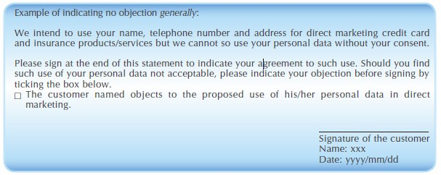“Consent” includes
an “indication of no objection”

Return the signed form but did not check the box indicating
objection = consent

New Regulatory Regime of Direct Marketing
Higher Penalties for Non-Compliance

 | Maximum Fine  (HK$) | Maximum  Imprisonment
Non-Compliance | 500,000 | 3 years
Non-Compliance if the personal data is provided to third party for its use in direct marketing in exchange for gain | 1,000,000 | 5 years

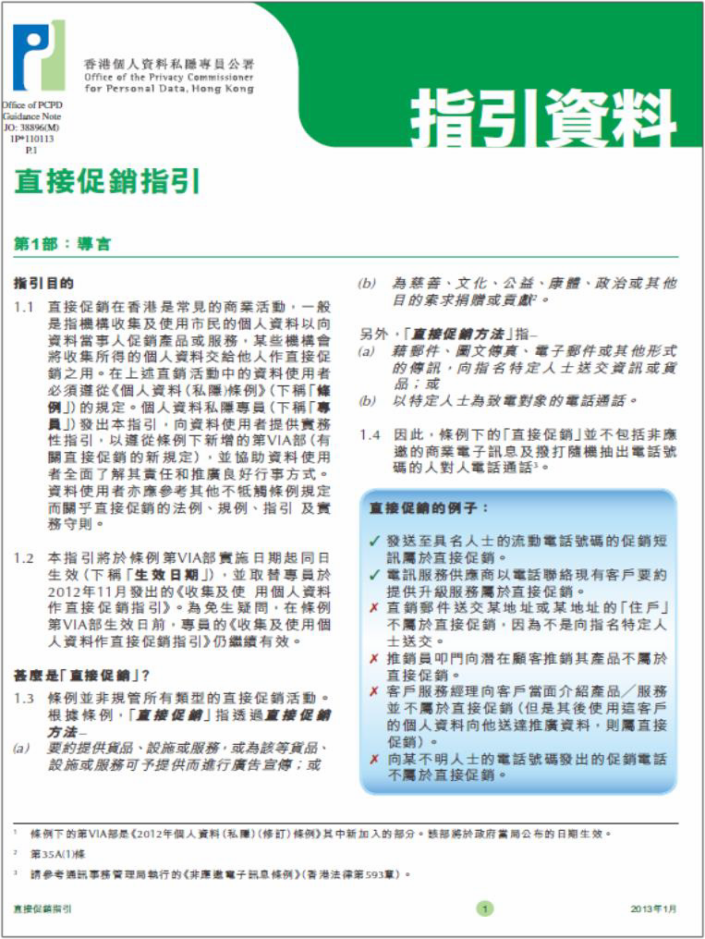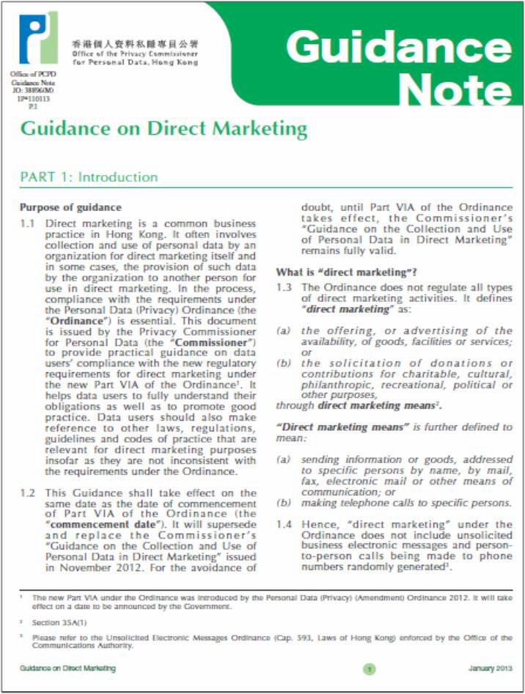Guidance to help data user

▪ "New Guidance on Direct Marketing"(Jan 2013 edition), explaining the requirements under the new regime and providing practical guidance to data users.

▪ Professional Workshop, to familiarise organisations with the new provisions and compliance measures.

Offences

• Contravention of DPP is not an offence. The Commissioner may serve an enforcement notice on the relevant data user directing the data user to remedy the contravention.

• Non-compliance with an enforcement notice commits an offence and carries a penalty of a fine at $50,000 and imprisonment of 2 years.

• Same infringement of the second time commits an offence and carries a

penalty of a fine at $50,000 and imprisonment of 2 years

• Repeated non-compliance with enforcement notice carries a penalty of a fine at $100,000 and imprisonment of 2 years, in case of a continuing offence, a daily fine of $2,000

32

Offences

• Section 64 provides that “A person commits an offence if the person
discloses any personal data of a data subject which was obtained
from a data user without the data user’s consent –
a) With an intent –
1) to obtain gain in money or other property, whether for the benefit of the person or another person; or
2) to cause loss in money or other property to the data
subject; or
b) the disclosure causes psychological harm to the data
subject.
• Maximum penalty: a fine of $1,000,000 and 5 years’ imprisonment

33

Compensation

• New section 66B : Privacy Commissioner can grant assistance to data subject in respect of these legal
proceedings

34

Code of Practice

• Identity Card Number and other Personal Identifiers

• Human Resource Management

• Consumer Credit Data

35

Guidelines and leaflets

• Information Leaflet: An Overview of the Major Provisions of the Personal Data (Privacy) (Amendment) Ordinance 2012

• Information Leaflet: Outsourcing the Processing of

Personal Data to Data Processors

• Information Leaflet: Offence for disclosing personal data obtained without consent from the data user

36

Guidelines and leaflets

• New Guidance on Direct Marketing

• Guidance on Preparing Personal Information

Collection Statement and Privacy Policy Statement

• Monitoring and Personal Data Privacy at Work

• Guidance on Collection of Fingerprint Data

• Guidance on CCTV Surveillance Practices

• Guidance on Data Breach Handling and the Giving of Breach Notification

37

Guidelines and leaflets

• Guidance on the Use of Portable Storage Devices

• Guidance for Data User on the Collection and Use of

Personal Data through the Internet

• Guidance on Personal Data Erasure and Anonymisation

• Proper Handling of Data Access Request and Charging

of Data Access Request Fee by Data Users

38

ii-AJUHt..••a*• Office of the Prfvacy Commissioner for Pc:rson1l OUa , Hong Jeong
Pnvacy Polley Statement Search S1te 01rectory Text Only Version j{

About PCPD

The Ordinance

Review of the Ordinance

PCPD Activities

Information centre > Media Statement: School websites

> ProfessionalWorkshops on Direct

PersonalData Privacy
Uberal Studies
found to have exposed student data
> Media Statement: Restricti ng Access to Company Directors' Personal Information
Protect Privacy by Smart Use of Smartphones (Leaflet pdO Annual Report 2011-2012 CpdO

New Guidance on Direct Marketing Consent and Opt Out Right in Direct Marketing
Legal Assi stance Scheme
Get to Know More
Marketing (and other new subjects)
> Public Seminars FREE
> Student Ambassador Programme
> TV Docu-dramaPrivacy Beyond Price"
> More

> FAO about My Privacy
Data Protection Principl es
Data Access Request Form COPS 003)
) Code of Practice

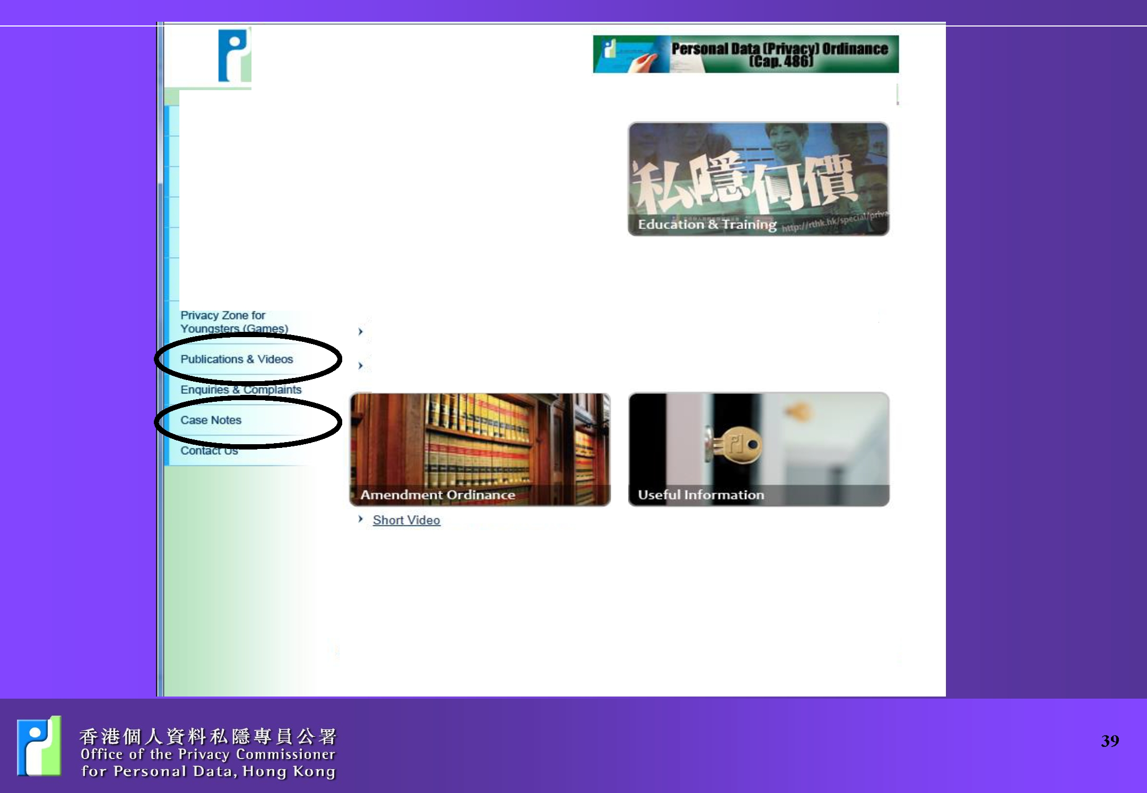

Nobcel Copynght 2001 Office of the Privacy Commissioner for PersonalData, Hong Kong. All rights reserved Disclaimer

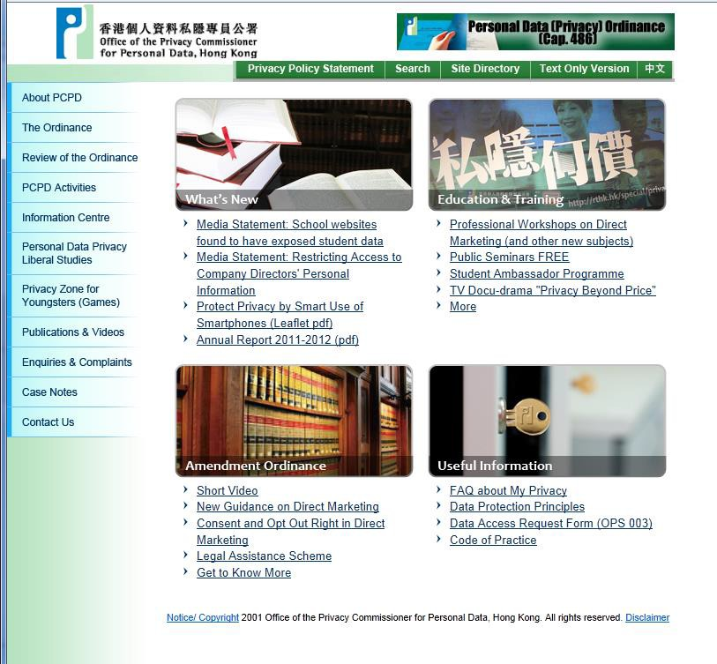Contact Us

❑ Hotline - 2827 2827

❑ Fax - 2877 7026

❑ Website - www.pcpd.org.hk

❑ E-mail - enquiry@pcpd.org.hk

❑ Address - 12/F, 248 Queen’s Road East, Wanchai, HK

© Office of the Privacy Commissioner for Personal Data, 2013
The above PowerPoint may not be reproduced without the written consent of the
Office of the Privacy Commissioner for Personal Data.

40

