EdUHK Resource Kit for SEN Students Benefits Local Schools

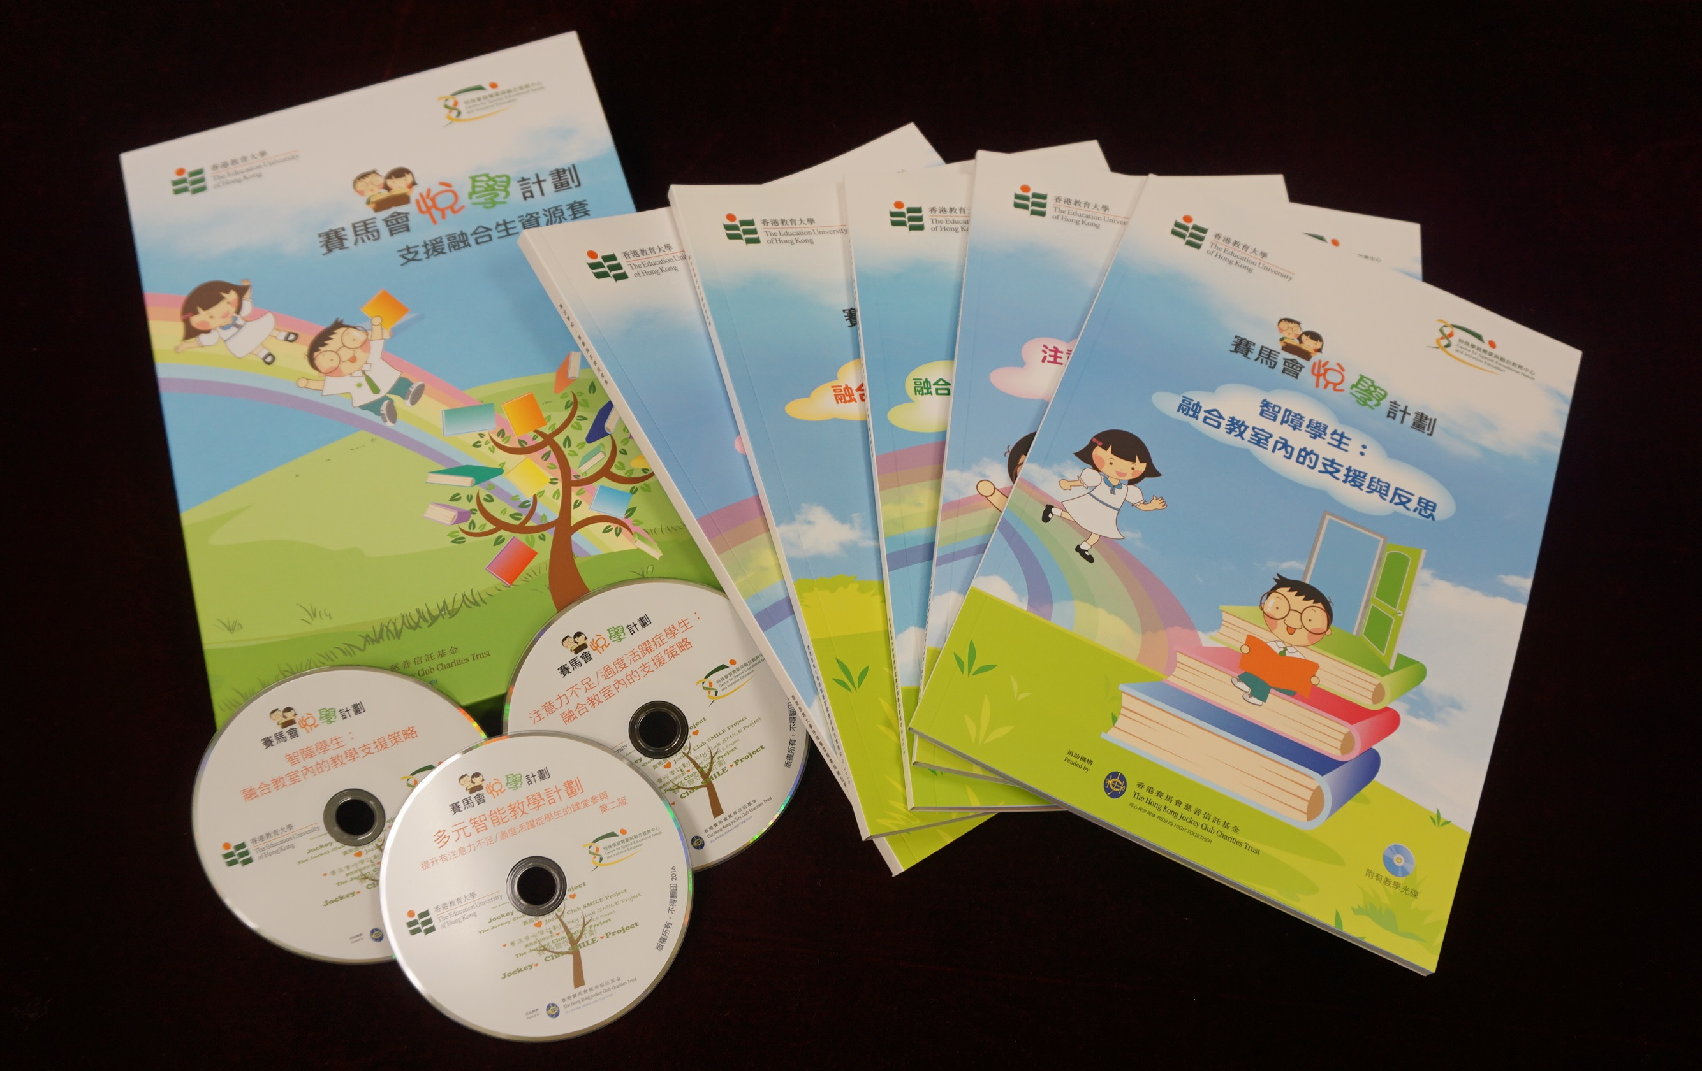
Supported by a donation of over HK$10 million from The Hong Kong Jockey Club Charities Trust, the three-year Jockey Club SMILE Project, undertaken by the Department of Special Education and Counselling and the Centre for Special Educational Needs and Inclusive Education (CSENIE), was completed in 2016. The project aimed to enhance the knowledge and skills of frontline teachers to support students with special educational needs, especially students with Attention Deficit/Hyperactivity Disorder (ADHD) and Intellectual Disability (ID). A total of 145 schools, amounting to 5,100 students with special educational needs, 7,400 teachers and 2,300 parents, benefited from the project. As part of the Centre’s ongoing efforts to foster knowledge transfer, the project team had prepared a resource kit based on previous experience and the project’s outcomes for dissemination to all schools in Hong Kong.

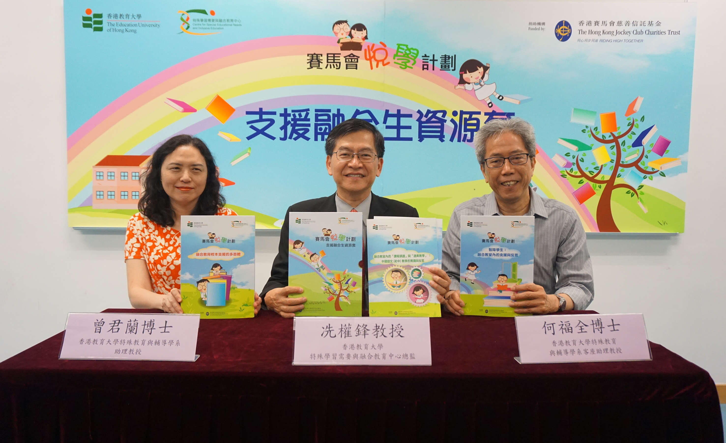
CSENIE held a launch ceremony on 12 May 2017 for the set of resource kit, and Professor Kenneth Sin Kuen-fung, principal investigator of the project and Director of CSENIE, said at the ceremony that “compared to existing teacher training models, the school-based and focus-based support strategies used in the Jockey Club SMILE Project are indeed innovative breakthroughs. The manpower and work coordination needs are more complicated than in general teacher training courses. However, the experience gained from this project has provided good reference for future teacher training and the development of inclusive education in Hong Kong”.

The set includes five books and three VCDs, namely:

※ Different Aspects of School-based Support for Inclusive Education
※ Students with Intellectual Disabilities: Support and Reflection for Inclusive Classrooms
※ Students with Attention Deficit/Hyperactivity Disorder: Support and Reflection for Inclusive Classrooms
※ Curriculum Adaptation and Differentiated Instruction in Inclusive Classrooms: Support and Reflection for Chinese Teaching in Junior Secondary Level
※ Inclusive Schools: Research in Relating to Teaching and Support

And themes of the three VCDs are:
※ Multiple Intelligence Teaching Programme: To Enhance the Classroom Engagement of Students with Attention Deficit/Hyperactivity Disorder
※Students with Intellectual Disabilities: Teaching and Supporting Strategies for Inclusive Classrooms
※Students with Attention Deficit/Hyperactivity Disorder: Supporting Strategies for Inclusive Classrooms

